

Excalibur Chess Help System
[Excalibur Chess Ltd.]
[Bella Vista CA]
[support\excalibur.net]
[January 11, 2025]
[10:37 AM

Excalibur Help System
Foreword

Excalibur Chess was designed and developed to provide a best in class interactive Chess application that combines the elements of Chess with a new highly customized set of actions that enable complete control over the chess board, and a broad selection of unique chess boards and distinctive chess pieces to choose from.
Excalibur Chess is a Windows desktop application providing heretofore unavailable capabilities such as saving and restore of previous games, history playback move by move, and most significantly chess pieces designed to emulate real-life chess sets as opposed to stick figures and line diagrams.

Excalibur Chess is available in 2 editions specifically, Standard and Merlin. The Merlin edition adds additional enhanced Chess Boards and Chess Sets, including the newly acclaimed Gay Pride selections, and US Politics . Additionally, during the introductory period, the Merlin Edition extends the 12 month license to 15 months. Excalibur Chess is supported by the parent website ExcaliburChess.net

Excalibur Chess can be played worldwide using desktop mirror imaging software provided by remote access software applications. A variety of remote access software exists, including Anyviewer™, TeamViewer™, AnyDesk™, and RemotePC™, with Anyviewer being the remote access software of choice. Internet access is required for this feature.

The installation and use of Anyviewer is described at AnyViewer. Anyviewer currently offers a ‘free’ version that is more than adequate to support Excalibur Chess.

While a myriad number of internet-based chess games abound, none offer the graphics, features and flexibility of Excalibur Chess Windows desktop application. The simple Diagrammatic figures in internet based games cannot compare with the beautiful chess sets available in Excalibur Chess. All chess sets displayed may be purchased at thechessstore.com.

It should br noted Excalibur Chess is not designed to be played against a computer, but rather between two players who are co-located or in any geographical location worldwide.

AF.Donato,
Designer and developer

Table of Contents

Table of Contents 3
Excalibur Video Clips 4
Initialization 5
Excalibur Chess Installation and Setup 6
Setup Window 9
Board Selection 10
Chess Sets 10
11
Undo 12
Help System 12
Captured Pieces 13
History 13
History Replay 13
History Messages 14
Action notation 14
Castling 14
Action Controls 14
Save and Restore Game 15
Save 15
Restore 15
Checkmate Analysis 15
Game Clock 17
Merlin Edition Politics Chess Set 18
Classic Openings and Defense 22
Classic OPenings Classic Defense 22
System Requirements 23
ToolTips 23
Target Tracing 25
Chat Window 25
Support / Feedback 27
Windows Behavior 28
Game Play 29
Anyviewer 30
Instructions for Anyviewer Remote Access Install 30
Connecting to another player 30
Casting to Smart TV 31
Attributions 31

Table of Figures

Figure 1 Registration Screen 7
Figure 2 Primary Window 10
Figure 3 Setup Window 11
Figure 4 Setup Icon 11
Figure 5 Board Squares 12
Figure 6 Staunton Black & White Figure 7 Copenhagen Staunton 12
Figure 8 Copper & Brass Figure 9 French Staunton 13
Figure 10 Italfama Figure 11 Medieval Theme 13
Figure 12 Reykjavik 13
Figure 13 Staunton Rosewood Figure 14 Medieval Theme 13
Figure 15 Templar Knights Figure 16 Traditional 13
Figure 17 Wellington Staunton Figure 18 Silver & Black 13
Figure 19 Undo Button 14
Figure 20 Help System 14
Figure 21 Captured Pieces Bar 15
Figure 22 Navigation Bar 15
Figure 24 Checkmate Analys 18
Figure 25 Game Clock 19
Figure 26 Republicans 20
Figure 27 Democrats 21
Figure 28 Game Play Select Screen 22
Figure 29 Politician Tooltips 23
Figure 30 System Settings Tooltip Figure 31 Help System Tooltip 25
Figure 32 White Queen Tooltip Figure 33 Black Bishop Tooltip 26
Figure 34 Arrows Tracing Figure 35 Borders Tracing 27
Figure 37 Support / Feedback Screen 29
Figure 38 Slider Resizing Bar 31
Figure 39 Visual Cue Next to Play 31

Excalibur Video Clips

They say a picture is worth a thousand words. Video clips can tell the whole story and are a major adjunct to this documentation. Listed below are supporting video clips that describe and visualize Initialization and primary features and functions of Excalibur Chess.Video clips are also available in the main application via the Setup screen.
- Remote Access

- Screen Capture

- Window Resize

- Politicians Gameset

- Checkmate Analysis

- Castling

- Openings / Defenses

- Introduction

- Orientation

- Features and Functions

- Setup

- Registration

- Chat Screen

Setup Screen access
Access the video clips by clicking on the Setup cogwheel in the lower right corner of the main screen. This will reveal the Setup screen where the option to Select Video Tutorials is located. Video files may be viewed in one of two formats by checking the radio buttons Media Player or Internet Browser. Media Player will play the video clip in the default media player on the user’s machine, while Internet Browser will play the video clip in the default browser.

Initialization
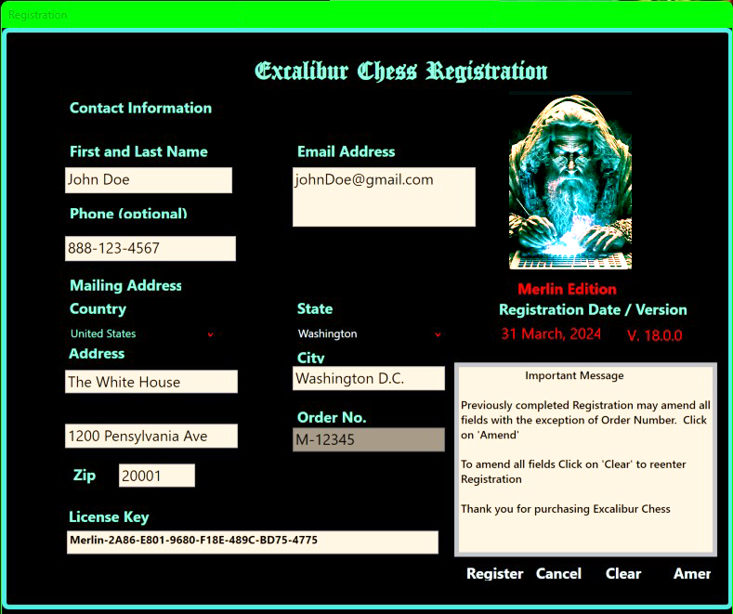
Figure 1 Registration Screen
Prior to beginning play the Registration screen must be filled out. A license key is generated, and user information is recorded. This will establish the necessary information to warrant the license for the period, which warranty, 12 months for Standard edition and introductory of 15 months for Merlin edition. Information may be reviewed and adjusted at any time by selecting ‘View Registration’ on the Setup screen.

Excalibur Chess Installation and Setup

Excalibur Chess requires the installation of Windows components that support the functionality and features that separate Excalibur Chess Desktop Editions from currently available internet based Chess platforms.

Note.. If Excalibur Chess is being installed on a new PC it may already have the required components installed. In which case the installation above will not appear and there is nothing further to do.

When first executing Excalibur Chess (from icon on Desktop), the following windows dialog is presented:
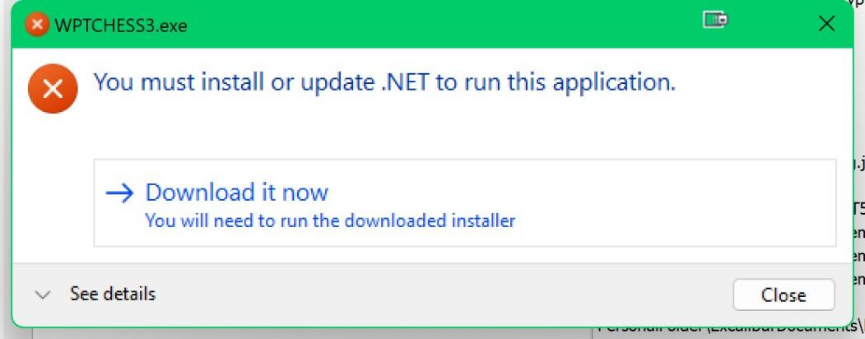

Click on ‘Download it now’. This will open a Microsoft website prompting to download the required component to the Downloads folder. Click on ‘Save’.
At the uppermost right corner of the displayed website is a Down Arrow. The progress of the download will continue until complete as illustrated below:

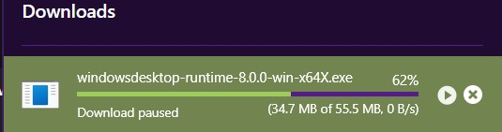

When complete Double Click on the following notice
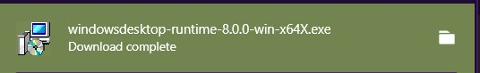
The following will be displayed:
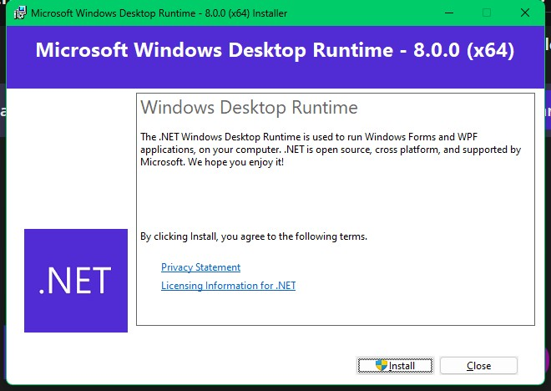
Click on ‘Install’.
Upon completion of the install the following will be displayed:
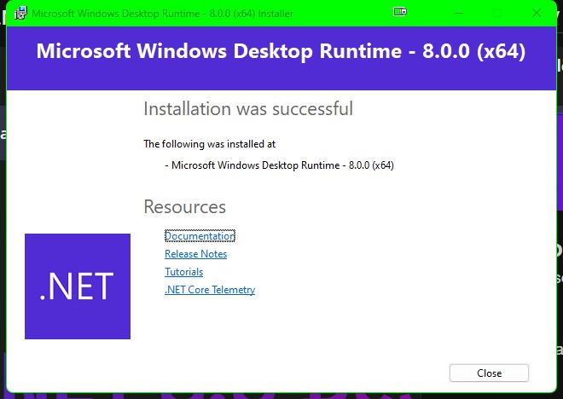

Installation of required supporting components is complete. This is a one-time process.
Click on Excalibur Chess icon on Desktop to launch Excalibur Chess.

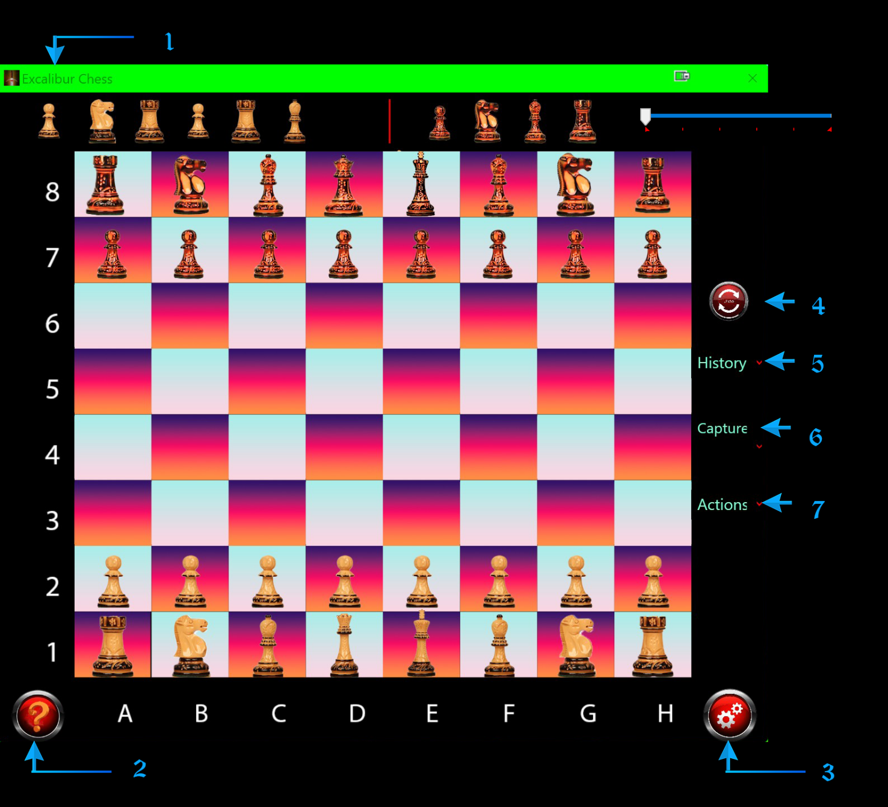
Figure 2 Primary Window

Legend
- Captures Bar - displays captured pieces
- Help System - invokes default Word processor to display Help System
- Settings - displays secondary window to select system options
- Undo Button - reverses last move (1 move only)
- History Dropdown - displays History replay options
- Captures Dropdown - select and turnon/turnoff Captures Bar
- Actions Dropdown - select various actions such as Save/Restore History and Board Reset

Setup Window

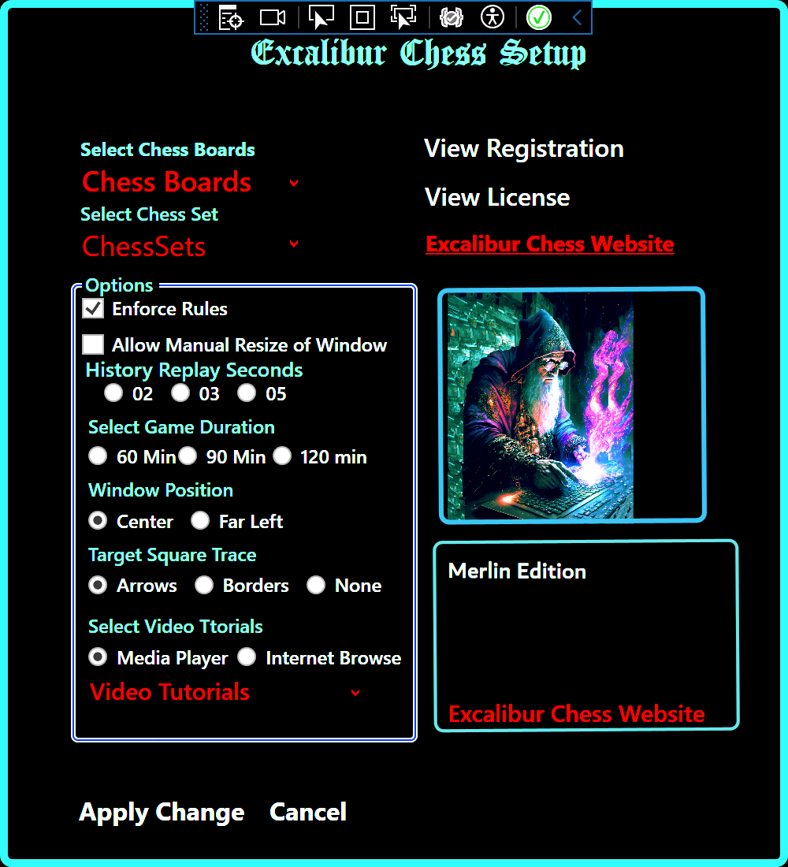
Figure 3 Setup Window

Setup is invoked by clicking on the cogwheel image in the lower right part of the screen. The Setup window will be displayed


Figure 4 Setup Icon

Setup Selections :
- Enforce Rules - All rules of chess are strictly enforced. i.e. moving a pawn 2 or more rows after initial move is illegal. Bishops must stick to their own colors. Rooks must only move horizontally or vertically within the same column or row
- History Replay Seconds - Select delay of moves when running in ‘Auto Replay’
- Manually Resize Window - Allow player to drag window up or down, left or right to resize window
- Select Game duration when playing against the Game Clock
- Window Position - Leftmost or Center of screen
- Target Tracing - Select Arrows, Borders, or None
- Chess Sets - Select Chess set from drop down list of available chess sets
- Chess Boards - Select Chess Board from drop down list of available chess boards
- Video Clips - Select tutorial video clip. Will play in system default media player

Note.. The default is ‘Enforce Rules’, adheres strictly to rules of Chess. ‘No Rules’ allows any piece to be positioned on any square on the board. This provides the greatest flexibility when examining alternate plays against pre-initiated classic openings. For normal game play the Enforce Rules option should be chosen

Board Selection
The standard edition of Excalibur Chess includes the following chess boards:

Gray Square Blue Square Red Square Gold Square

Figure 5 Board Squares
Board selection should be performed first as it will cause an automatic shutdown and restart of the application
Additional Chess Boards are available in the Merlin Pro Edition

Chess Sets

Chess sets available in Excalibur Chess standard edition include:
- Prime Staunton Staunton Black and White Reykjavik British Staunton Rosewood
- Silver and Black Medieval Theme
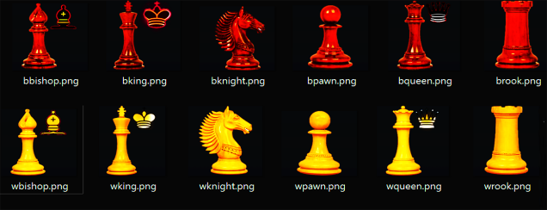
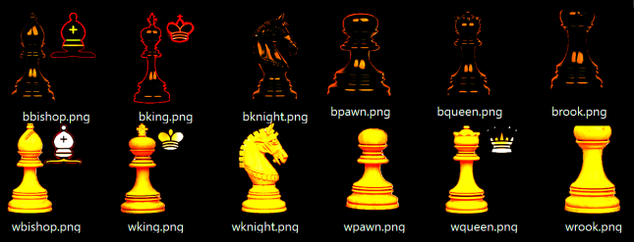

Figure 6 Staunton Black & White Figure 7 Copenhagen Staunton
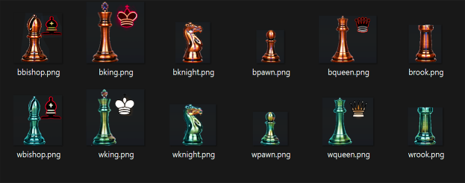
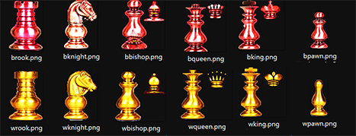

Figure 8 Copper & Brass Figure 9 French Staunton
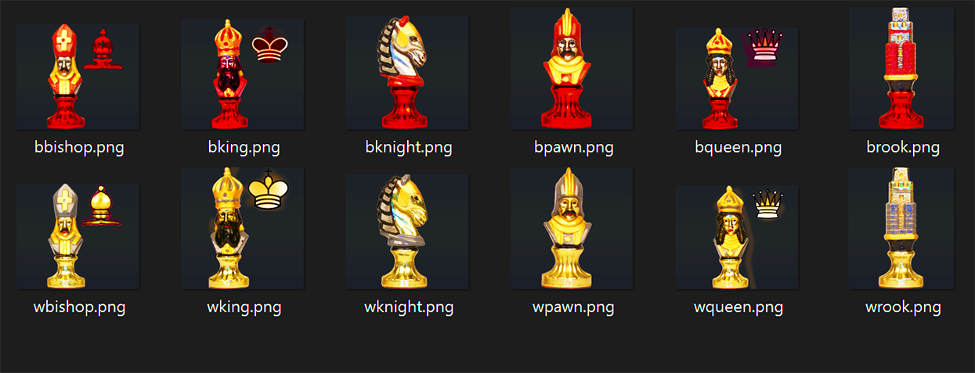
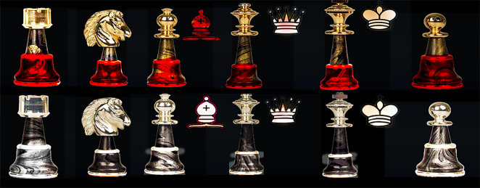

Figure 10 Italfama Figure 11 Medieval Theme
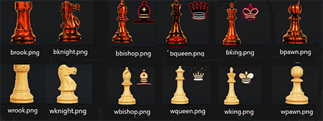

Figure 12 Reykjavik
Figure 13 Staunton Rosewood Figure 14 Medieval Theme
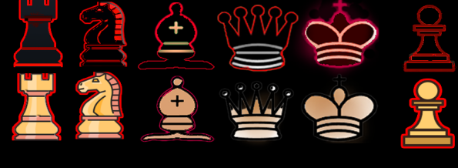
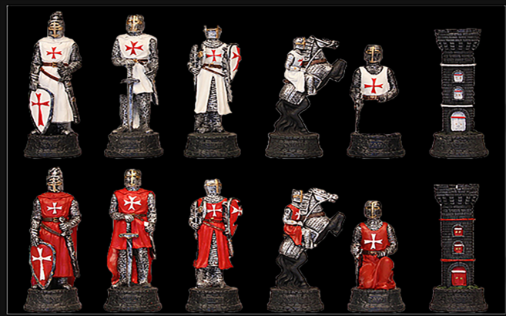

Figure 15 Templar Knights Figure 16 Traditional
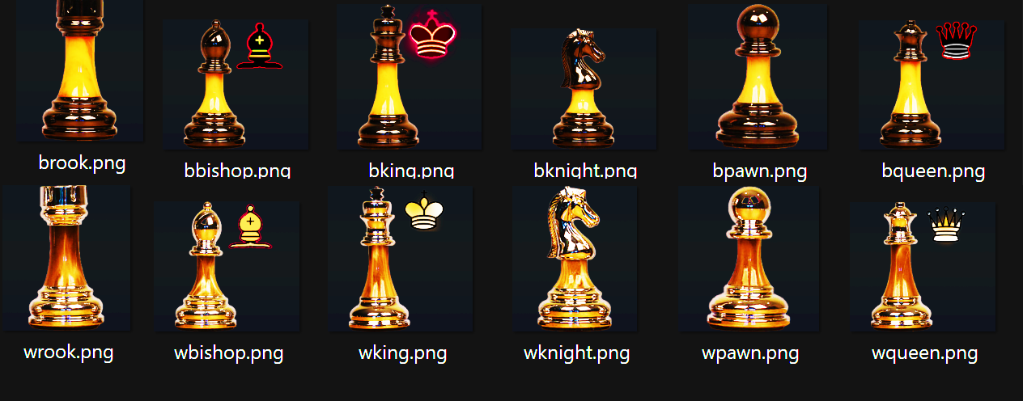
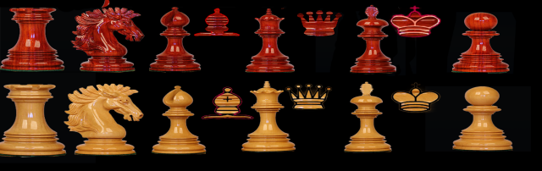

Figure 17 Wellington Staunton Figure 18 Silver & Black
Additional chess sets are available in the Merlin Pro Edition including the custom designed and developed ‘Politics’ chess set. A unique one -of-a-kind fully customizable set of your favorite Republican and Democratic politicians and supporters squaring off in Excalibur Chess. See Merlin Edition Politics Chess Set for details.

Undo

The Undo function is selected by clicking on the Undo control in the upper right corner of the screen. This will cause the last move to be reversed and allow the player to redo the move. This is a single step control.

Figure 19 Undo Button

Help System

The Help System is selected by clicking on the Help control in the lower left corner of the screen. The Help document previously stored in the users Documents folder will be displayed by the default Word application in the users system associated with .docx documents. e.g. Word.exe or any other word processing application in the system defined as the default application.


Figure 20 Help System

Captured Pieces

Throughout the game a display of the current captured pieces may be invoked by clicking on the 'Captures' control 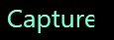 button at the right side of the screen. This will cause a display of the current captured pieces as illustrated below.

Figure 21 Captured Pieces Bar

History

Each move is being recorded and saved within the application. All moves to date may be viewed at any time by clicking on the 'History' control  button at the right side of the screen.

History Replay

History Replay is a multi-faceted control causing the game to be visually replayed a move at a time with a default 5 second delay between moves. The delay may be reset in the Setup Dialog referenced above.

History Navigation Controls
 Reset to beginning of History
 Single Step through History
 Pause Autoplay
 Auto Replay through History
Figure 22 Navigation Bar

History Messages

The format of History Messages emulate the standard algebraic chess notation with enhanced additional features. Specifically,


Figure 23 History Messages

In this example, this message will appear after the white pawn at board position column ‘E’ row position ‘2’ was moved to column ‘E’ row ‘3’

Action notation

=> - Moves illustrates a square to square move
>> - Check King illustrates a move that resulted in a king check
<> - Captured illustrates a move that resulted in a captured piece
== - Castled illustrates a castled move

Castling

Every avid chess player knows the importance of castling. When the option to castle is determined by the application one of more arrows will be displayed at the bottom of the screen for White and the top of the screen for Black. The left-most arrows signify the availability of castling on the Queens’s side, while the right-most arrows signify castling on the King’s side. The direction of the arrows indicates which side, kings side or queens side castling is enabled for. It is entirely possible that both sides may become available before any castling takes place. Clicking on the arrows wil cause automatic castling of the rook and king depending upon which selection was made. Once castled, the option to further castle is removed and arrows will no longer be displayed for that player.

Action Controls
The Action Controls drop down function 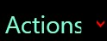 at the right side of the screen allows selection of the following features:
- Reset Board - Resets board to a clean position allow start of new game
- Save Game - Saves board image to Documents folder
- Restore Game - Restores Board image from previous save
- Open Chat - Opens Chat Window
- Quit Game - returns to Splash Screen - continue or exit game (right click).

The Actions Control drop down list is displayed when the mouse is hovered over the Actions Control.

Save and Restore Game
A key feature of Excalibur Chess is the ability to save a game at any point of play. Board positions are saved in the systems Dcuments/ExcaliburConfiguration/Games' folder. This ensures consistency with Windows best practices. This is one of the selections from the drop down 'Actions' controls. The saved file may be shared with any player having a licensed copy of Excalibur Chess. The ability to restore and single step or auto step through the saved game is unique to Excalibur Chess. A great way for player review to analyze the moves that led to victory or defeat. An excellent learning tool.
Additionally, play may be resumed from the last saved position.

Save
All games are saved with the filename reflecting the computer date and time game was saved. Ex. ‘Sunday, 19 Nov, 2023 2.20pm’. A maximum of 5 games may be saved. When more than 5 games are saved, the game with the oldest date is deleted, thereby maintaining the game total saves at 5.

Restore
After selecting ‘Restore’ from the Actions Control, a 2nd click or hover on the control will display a drop down list of up to 5 saved games (Merlin Edition). Click on the game to be restored.

Checkmate Analysis
Setting apart Excalibur Chess is the unique functionality of viewing existing and available paths to checkmate the king. Selecting Checkmate Analysis from the drop down Actions control reveals the following window image.

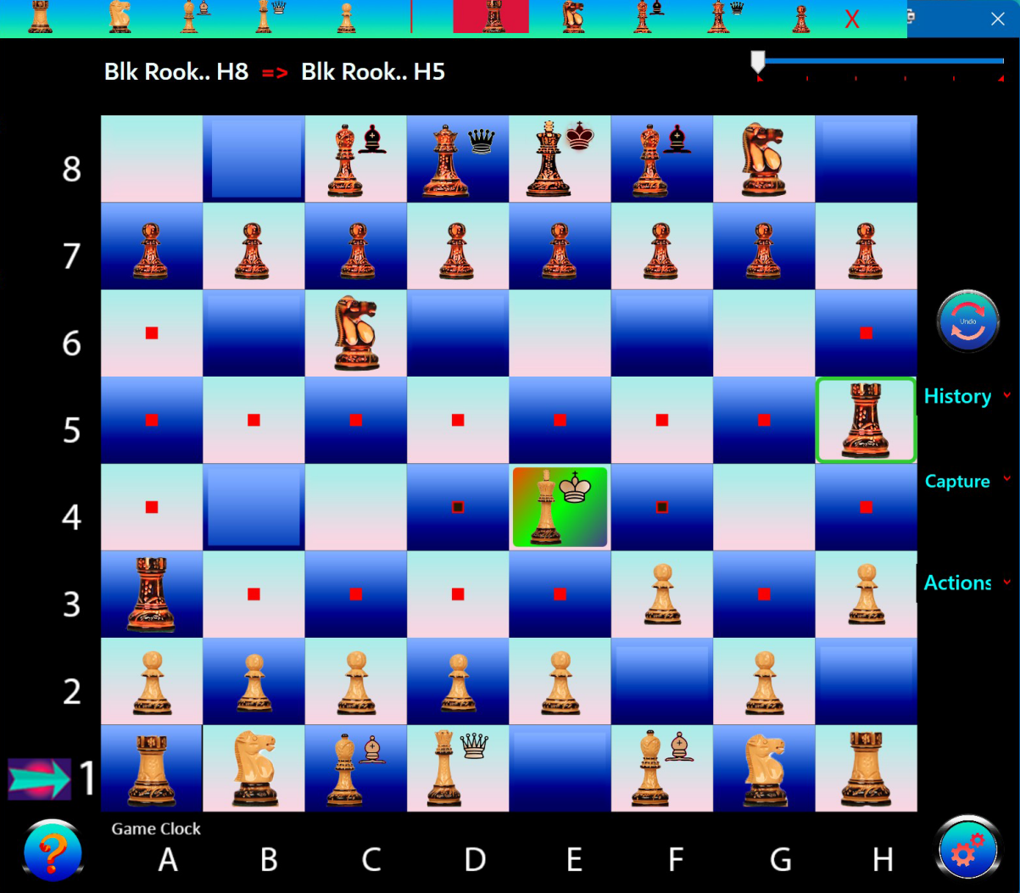

Figure 24 Checkmate Analys

Initially the board is portrayed without any path indicators. The title bar presents the white and black chess figures to select from. As illustrated, the Black rook was selected. This produced the above image with red squares illustrating the squares covered by the rook’s path. The opposing king will show black squares with red borders showing the open available positions the king may move to. Note the available squares only relate to open positions not covered by the rook. Had the black knight been selected square D4 would have been replaced with a red square, removing that square as an available open position for the king. The board will be refreshed by either clicking on the red X in the title bar or simply executing the next move.
An excellent, unique tool for any chess player, seasoned or amateur to plot a strategic plan of attack.

Game Clock

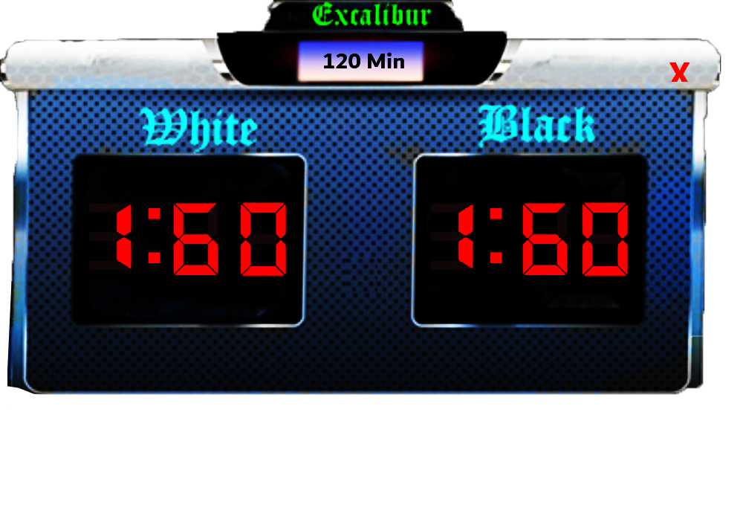
Figure 25 Game Clock

The Excalibur Chess Merlin Edition Game Clock can be set in the ‘Setups’ screen to either 60, 90, or 120 minutes. The Game Clock is initially hidden and can be displayed by selecting ‘Game Clock’ from the drop-down Actions menu. The Game Clock can be closed by clicking on the Red ‘X’ in the upper right corner of the display.

Methodology: When White completes a move, the timer is started for Black. Upon completion of Black’s move Black’s clock is reduced by the elapsed time and White’s clock is started. As above, when White completes a move, White’s clock is reduced by elapsed time is.

Merlin Edition Politics Chess Set

Face off with your favorite politicians from both Republican and Democratic parties.
Excalibur Chess offers a wide variety of politicians and supporters from both parties, with current photographs, which may be assigned to any the 16 chess pieces for both black and white. Note that either party can be assigned to either color. While the standard Staunton Reykjavik chess set is the playing model, the Tooltip for each piece is displayed with the picture of the politician assigned to that piece. Politician assignment is performed at the game level and may be reconfigured at any time a new game is started by simply following Setup instructions and selecting ‘Politics’ from the drop down selection control. Sample Politician assignments are illustrated below:

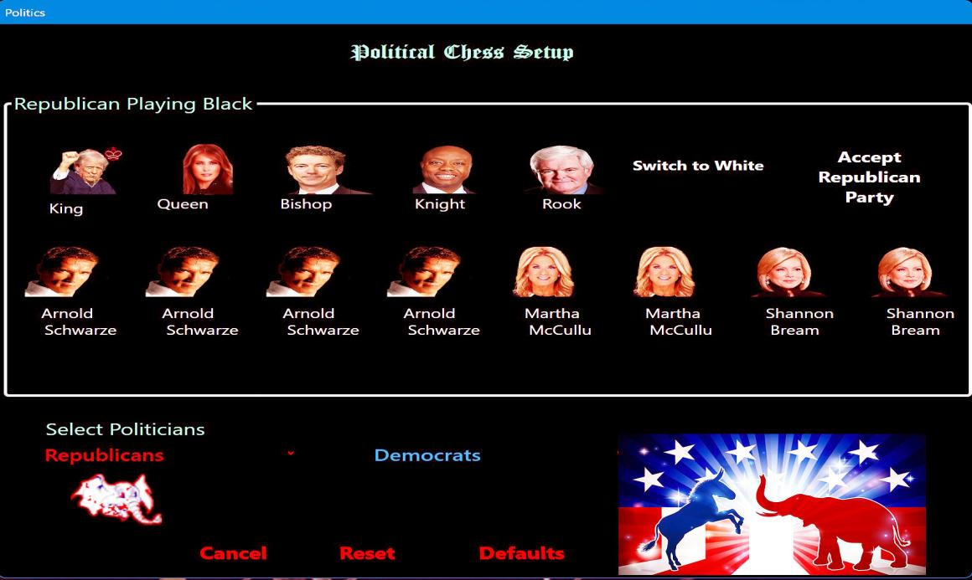

Figure 26 Republicans
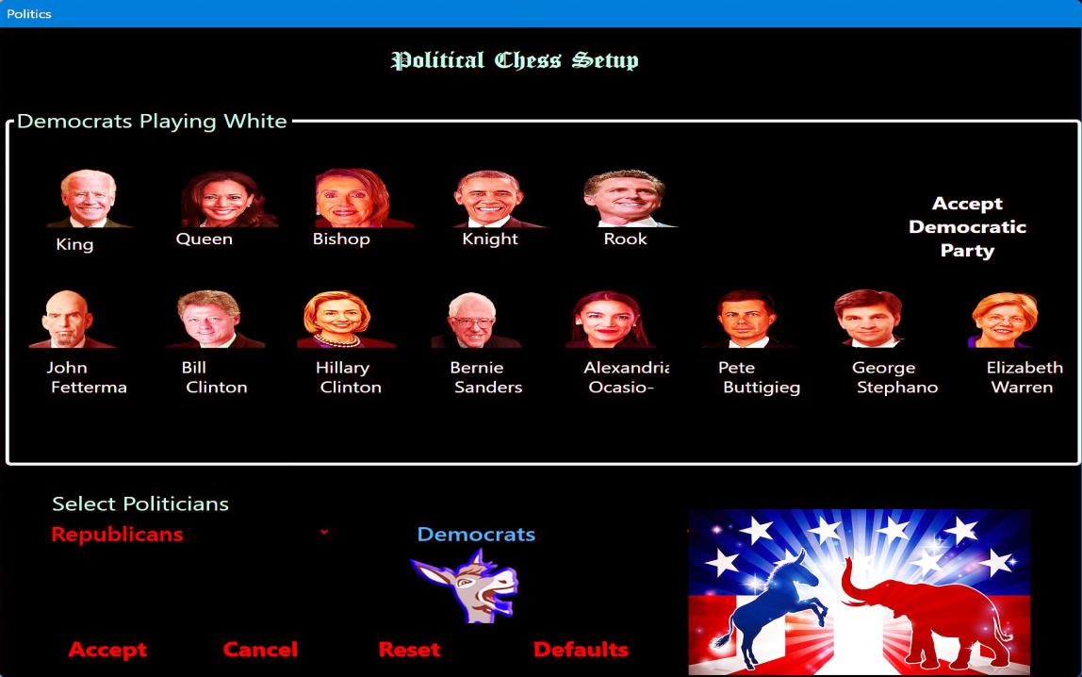
Figure 27 Democrats

Click on ‘Accept Democratic party’ to display final politician Selection Screen

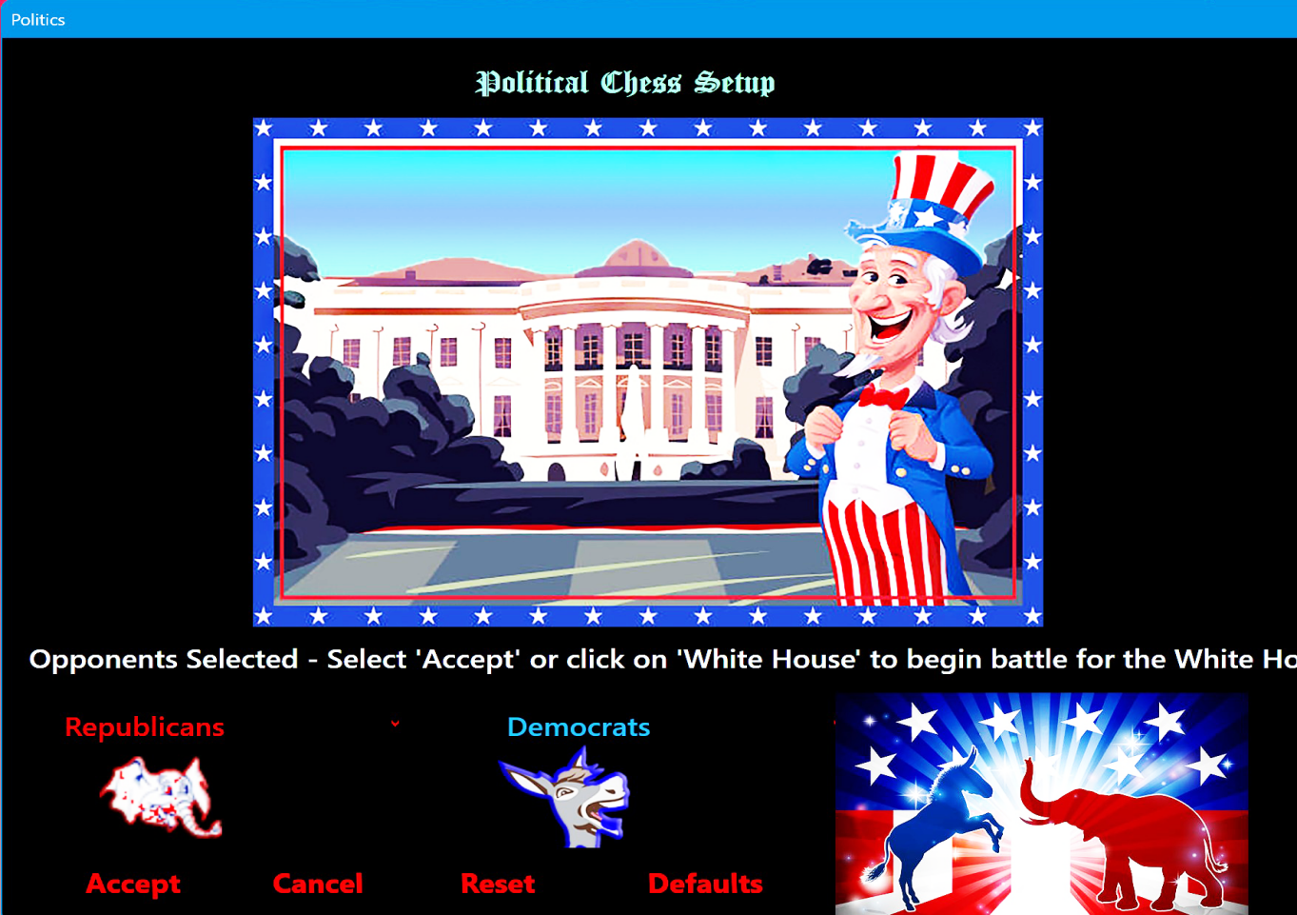
Figure 28 Game Play Select Screen

To begin game play either click on the picture or depress the ‘Accept’ button at the bottom of the screen. Additional options are: ‘Cancel’ which will redisplay the main chess board screen, or ‘Reset’ which will clear all previously selected politician images and allow reselection of a new set of images.

Of particular note is the Control Button labeled ‘Defaults’ at the bottom of the screen. Depressing the Defaults button will populate all pieces with a preselected set of politicians. Any of these presets may be overridden by selecting from the respective political party drop-down control. This is an arbitrary default selection and does not represent any particular point of view with respect to assignment of politicians.
Note… Default assignments are completely optional.

There is a wide variety of politicians and supporters to select from, currently 24 from each party. Note that upon special request additional political figures can be included.
Shown below are sample Tooltips displayed by hovering over the individual square.

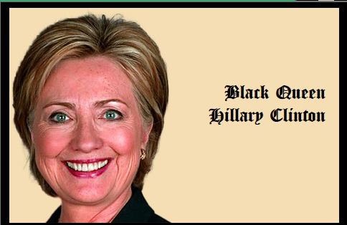
Figure 29 Politician Tooltips

Additionally, Tooltips are displayed by hovering over captured pieces.

Politics Chess is selected from the Setup window which presents a drop down control for each party listing the current set of politicians and supporters. Republicans are selected first, and the color may be selected at this time. Select a politician from the Republican drop down control and click on the chess piece you wish to associate the politician with. Continue till all chess pieces have been assigned, then slick on ‘Accept Republicans’. The screen will then be directed to assign the Democrats. Repeat as above selecting from the drop down Democrats control. When complete click on ‘Accept Democrats’ ,
or as prompted by the scrolling message ‘ Click on Whitehouse image to begin play.‘Cancel’ to return to main board, or ‘Reset’ to clear the screen and redo the assignments.

Classic Openings and Defense
Excalibur Chess provides a rich preset game environment of more than 10 of the recognized ‘best in class’ Openings and Defense strategies. In addition to providing newcomers to the world of Chess with a foundation to build upon, it offers an excellent teaching tool to explore the various strategies to players of all skill levels. Listed below are the classic Openings and Defenses provided by Excalibur Chess.

It should be noted that online Chess sites offer descriptions and flat images of common openings and defense strategies, while Excalibur Chess is the only application that allows playing of the game after setting the board for one of the classic openings or defenses.

In addition to selecting Classic Openings from Excalibur Chess, you may set the chess board directly from the links listed below. Simply hold down Ctrl key and press Enter. Excalibur Chess will immediately open to the desired classic openign.

Important Note… Due to limitations of invoking application from a word document Target Tracing has been turned off. Other limitations may apply.

Classic OPenings Classic Defense
- Bogo Indian Defense

- Grunfeld Defense

- Benko Defense

- Benoni Defense

- Queens Indian Defense

- Kings Indian Defense

- Slavs Defense

- Nimzo Indian Defense

- Classic Sicilian Defense

- Sicilian Scheveningen

- Sicilian Najdorf

- Sicilian Dragon

- Sicilian Four Knights

- Sicilian Kalashnikov
- King'sGambit

- Queens Gambit

- Ruy Lopez

- Catalan Opening

- King's Bishops Opening

- King's Fianchetto Opening

- King's Indian Attack

- Reti Gambit

- English Opening

- Vienna Opening

- ItalianGame

- Scotch Game

- London Opening

System Requirements
Excalibur Chess is a standard Windows Desktop application. As such, it can be played on any windows machine supported by Windows 10 or later. The methods of operation are:
- Desktop - Single player
- Desktop - Multiple player
Excalibur Chess was designed to be played most effectively on any Windows computer with 2 mice/touchpad or any 2 computers connected via remote access software. This is an ideal situation for mass-transit travel such as by airplane or train. No concern on dropping or losing pieces. When 2 computers are connected by remote access , players may be physically located geographically any place in the world. Modern transportation today, airplanes, trains, ships, are equipped with Internet access, thereby enabling Excalibur Chess to be played with players in any part of the world while travelling. See remote access software Anyviewer for directions on installing Anyviewer on your machine.
Note.. A ‘Remote Access’ icon has been placed on the users screen. This will bring up the download website to install Anyviewer

ToolTips

While there is is no substitute for reading this Help document, Excalibur Chess is enhanced with custom ‘ToolTips’ on every major control. ToolTips are displayed when the mouse or finger press is hovered over the major controls. Examples follow:

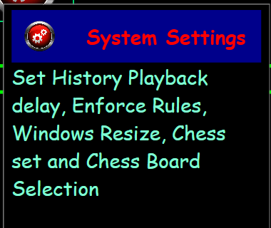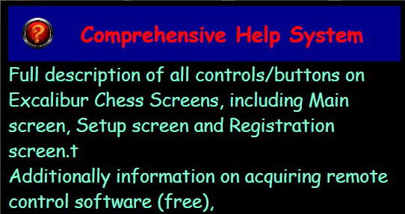
Figure 30 System Settings Tooltip Figure 31 Help System Tooltip
Additionally, all chess pieces have a tooltip displayed when the mouse is hovered over the square. Examples follow:

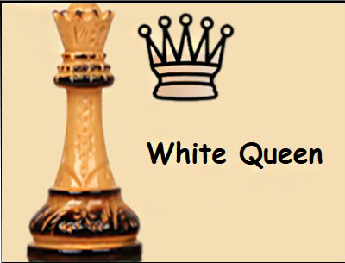
Figure 32 White Queen Tooltip Figure 33 Black Bishop Tooltip

Target Tracing

The two options for target tracing may be selected in the Setups window. The choices are ‘Arrows’ or ‘Borders’. This feature may be turned off by selecting ‘None’ from the Setup window.

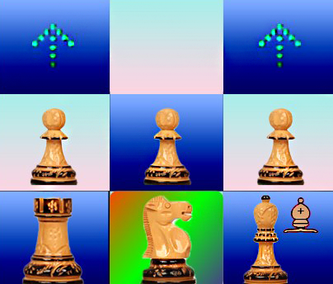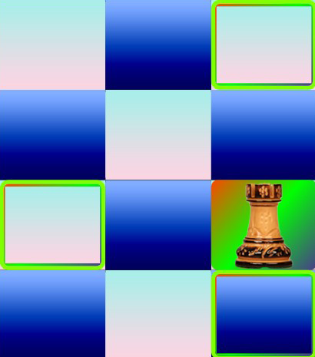
Figure 34 Arrows Tracing Figure 35 Borders Tracing

Chat Window

The Chat Window is accessed from the Actions drop down control. The Chat Window will be displayed adjacent to the main window and will stay opened until closed by clicking on the exit point (X in upper right hand corner).

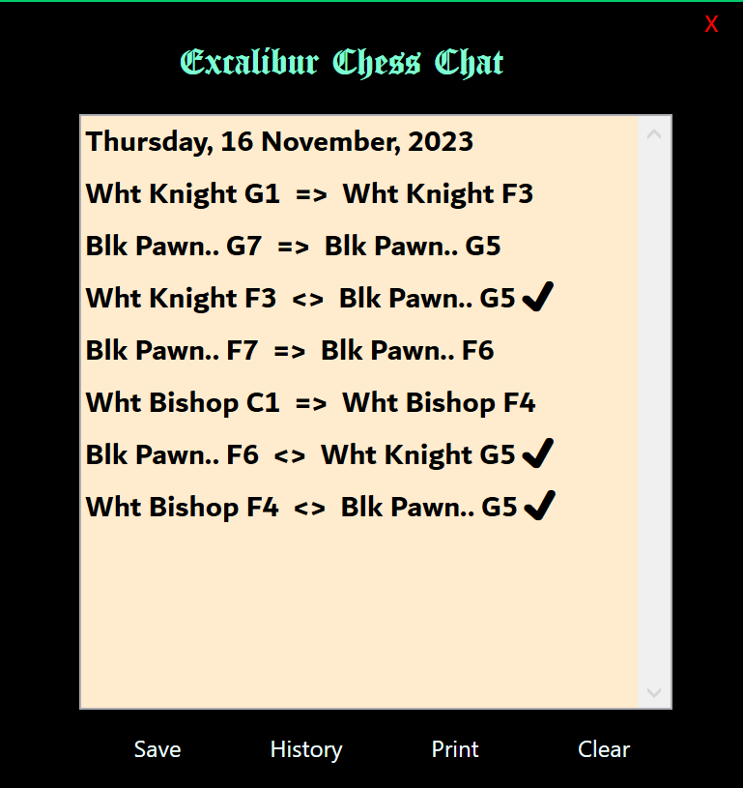
Figure 36 Chat Window

The Chat Window is a unique extremely versatile Window. As illustrated above the current history is displayed which may subsequently be saved and/or printed.
It also serves as a communication instant messaging facility between remote access players. Either player may enter text which will be displayed on the alternate player’s screen. An excellent way to share game detail with anyone by simply attaching the saved file to an eMail address.

Support / Feedback
A critical component of any properly designed and executed application is the ability to support the end user should a technical issue arise. The Technical team of Excalibur Chess is committed to providing rapid access and resolution should a problem arise with the software. As such, illustrated below is the ‘Support/Feedback’ display screen to provide vital information in defining and resolving any problems that should occur.

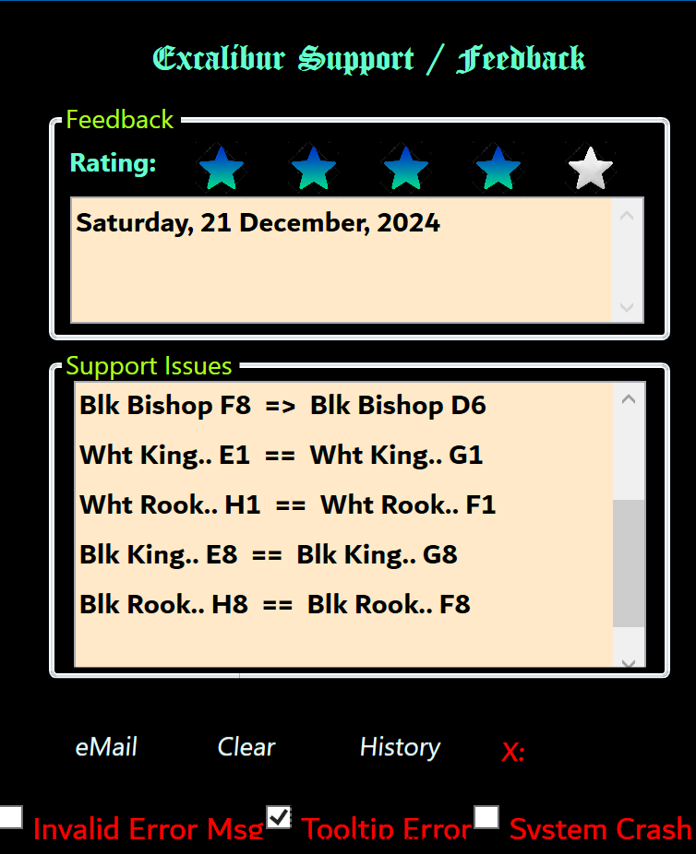
Figure 37 Support / Feedback Screen

When providing Feedback select 1 to 5 stars and provide opinions/requests just below the date. If this is a support issue, press space bar, or hit any key in the Support Issues box. This will then list the current History to date. Add any additional information below the last History line. Three checkboxes have been provided to further narrow down the issue if they apply. When complete click eMail to send to Technical Support.

Windows Behavior

Excalibur Chess has been designed for maximum performance on virtually any size computer. To best accommodate machines of virtually any physical size with monitors equally of any size, Excalibur’s Setup screen provides the following options:
- Resize Manually - provides the capability of window resizing by grabbing any of the 4 corners of the window and pulling in or out, up or down. Screen resolution is automatically adjusted to accommodate most monitors and laptops.
- Set GameClock duration: 60, 90, 120 minutes
- Set Target Tracing: Arrows or Borders
- Set Window position: Center or Far Left
- Turn Chess Rules on/off

Slider Bar - Click or tap and drag to resize window in 10% increments
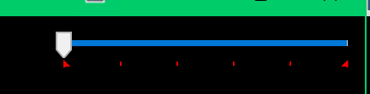
Figure 38 Slider Resizing Bar

* It should be noted that manually adjusting the window size may provide some distortion on the ‘Show Captured Pieces’ feature. To view Captured Pieces without distortion simply pull resized window in or out, up or down or click the slider bar. Window may then be manually sized as before. This is the only feature effected by manual resizing and will cause minimum disruption to play. Selection of window resize by any of fixed percentages cause 100% resolution on any windows computer.

- Excalibur Chess is warranted to perform on any windows computer with a screen size minimum of at least 13” wide and 8 1/2 “ in height. Best screen resolution - 1920 / 1080. Display quality and distortion free performance will be negatively effected by any computer not meeting these minimum requirements.

Game Play

As is customary in Chess, White will move first. Play is initiated by player clicking on piece or square they wish to move. This may also be accomplished with a touch screen computer by simply touching squares. This internally is registered as first click. The second click is the receiving or target square. Visually the squares of selection and move are highlighted with colored backgrounds. When a piece is captured the captor piece is highlighted in a distinctive color background. Additionally the captured piece is added to the internal captured array of captured pieces.

When a move puts the opposing player's king in check, both the piece causing the check and the checked king are highlighted in a distinctive color.

Player’s Turn to Move - a visual cue is displayed to further identify which player’s turn it is to move.
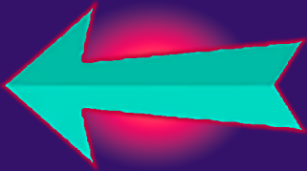
Figure 39 Visual Cue Next to Play
Note. it is not necessary for Excalibur Chess be installed on both player’s computers, only the player designated as the host.

Anyviewer

Through the use of any remote access software, Anyviewer™ being the software of choice, Excalibur Chess offers the only Desktop Chess game that can be played by 2 players geographically any place in the world. Anyvieweroffers a free, single person plan and is easy to setup and install on your computer. You may download Anyviewer at Anyviewer Download or click on icon installed on your desktop by Excalibur Chess. Follow the simple installation instructions. remote access software must be installed on all player’s machines wishing to play Chess in separate locations in this exciting feature of Excalibur Chess. Player’s co-located do not need remote access software to enjoy Excalibur Chess.

Instructions for Anyviewer Remote Access Install
Select and click the Windows download icon:

- Save the AnyviewerSetup.exe in your Downloads folder (this screen is automatically displayed, hit the Save button at bottom right of your screen)
- When Download completes click on downloaded file in your Downloads folder. Follow prompts to install Anyviewer
- Follow prompts to create an account (no obligation, no cost). This will provide easy connect to other players.

Connecting to another player
- Anyviewer will put an icon on your desktop:  Click to open Anyviewer Connect Window
- You may also launch Anyviewer Connect window directly from Excalibur Chess main window by clicking on the globe in the lower left corner of the main window  Note: Globe will be visible for 10 seconds and then will revert to Help icon, the question mark
- Your DeviceID, a 9 digit number is displayed
- A temporary Security code is displayed, case sensitive (similar to a password0
- The Partner ID box is where the Device ID of the opposing player is entered
- You are prompted to either enter the temporary security code of your opponent or send an email requesting access to the opponent’s machine.
- It is easier to enter the partner’s temporary security code which it assumed was transmitted to you either by text,email, or voice.
- If your partner has not started Anyviewer they should do so now
- You have two options.
  - Partner will host Excalibur Chess
    - To connect with player who will host Excalibur Chess, enter your Partner’s ID which they will provide to you
    - Enter your partner’s temporary security code which they will provide to you
    - You will then be connected to your partner’s computer and may begin to play Excalibur Chess
  - You will host Excalibur Chess. Give your partner your ID and temporary security code and they can then connect to your computer where you will host Excalibur Chess

Casting to Smart TV

You may simulcast your PC screen to a Smart TV for the ultimate playing experience. Directions on how to simulcast your PC to a Smart TV may be viewed
At Casting to Smart TV

Attributions

The following graphic images used to illustrate Excalibur Chess are attributed to:
Vecteezy.com


Figure 40 Attributions

The following image is a graphical image of a world-famous chess set. Photographer unknown

. .